MMS Expansion Update #2
March 28, 2024

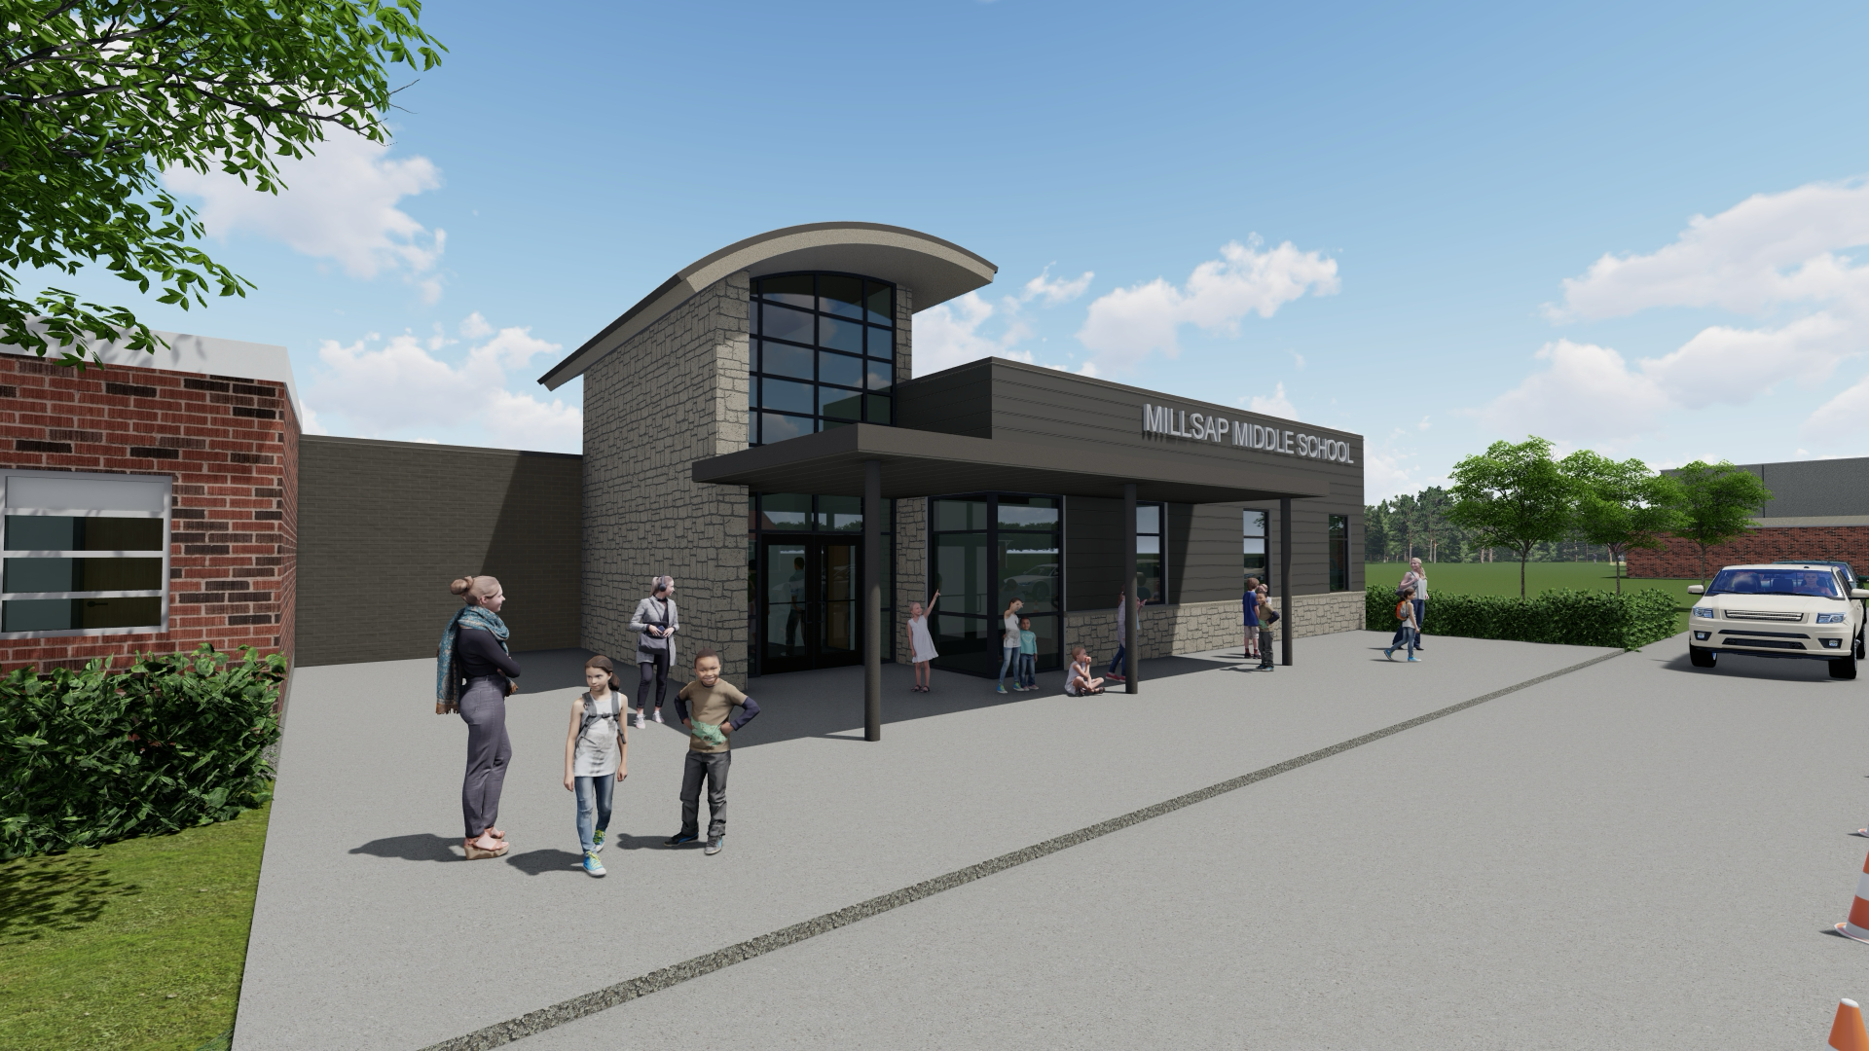

The above is an artistic rendering of the new entrance of Millsap Middle School. The new entrance would be accessed by a circle drive on the north side of the current building.

